



Helpful tips and usage instructions for your Queen’s IT application
TIP SHEET

Application(s): QCBR Timecard  Release Date: July 2021 | Audience: QCBR Managers and Staff | Facility: PB

The QCBR timecard application is used to track the staff’s time spent. This database helps allocate their time and effort per cost center. QCBR utilizes Kronos; however, there needs to be a trail of how those hours were designated in Kronos by the timekeeper. Queen’s is audited every year under the Uniform Guidance regulations by external auditors. This is a condition of receiving a certain amount of federal awards. When the auditor comes in, they look at our policies and procedures to ensure they adhere to the federal regulations and test for weak points.


Employee Time Card Entry

Each time period, an Employee needs to enter their own time by selecting the Time Entry menu choice.
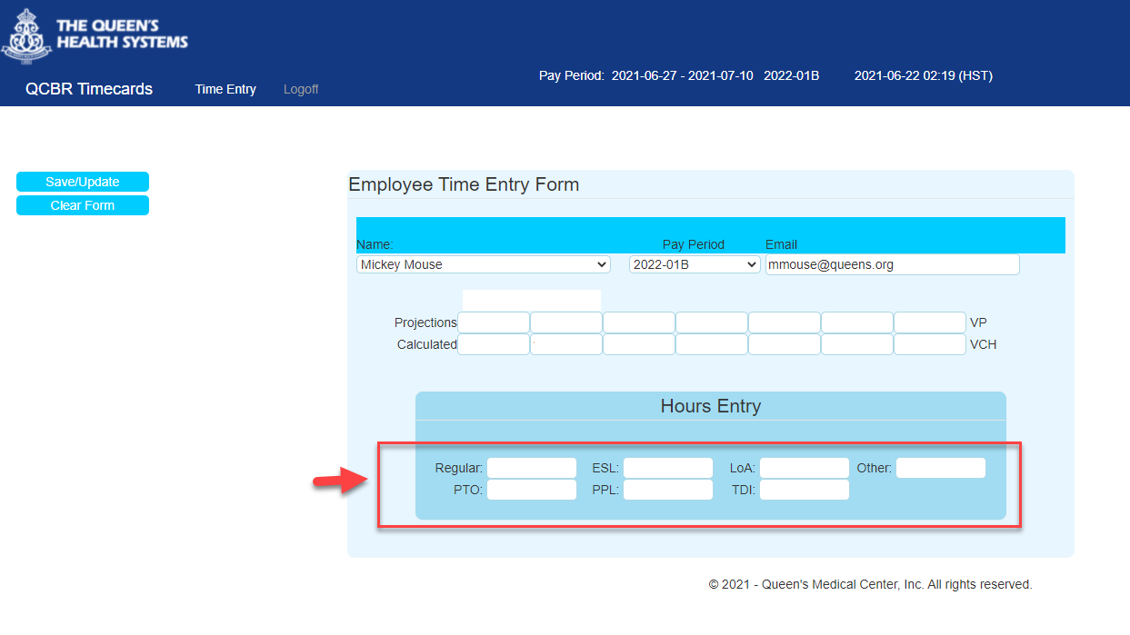

This will include the time they worked and any time exceptions (PTO, Sick, LOA, etc.) Once they login, it will show the current pay period.
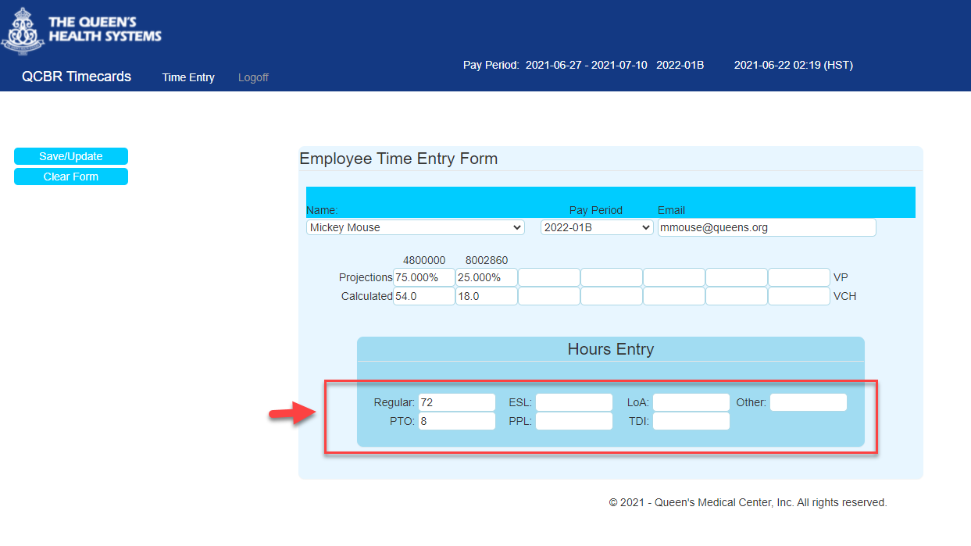
The employee enters data only in the hours entry box. It will automatically split their hours amongst their grant percentages. The PTO will be account will be charged separately against their home cost center.

