



Helpful tips and usage instructions for your Queen’s IT application
TIP SHEET

ECOSYS M6635cidn | Audience: QCBR | Version: July 2021

The ECOSYS device is located in the room 811. It’s a printer, fax, copier and scanner. This Tip Sheet and the full manual can be found in the QCBR intranet. For service or supplies, please call 808-691-HELP (4357) or email helpdesk@queens.org.


Operation Panel

- The Home button will bring you back to the main (Home) menu screen.
- The Status/Job Cancel button: light gives you feedback on status. Press the key to cancel any job.
- The Copy button will bring up the Copy menu.
- The Send button will bring up the Send menu, which is used to SCAN documents.
- The FAX button will bring up the Fax menu.

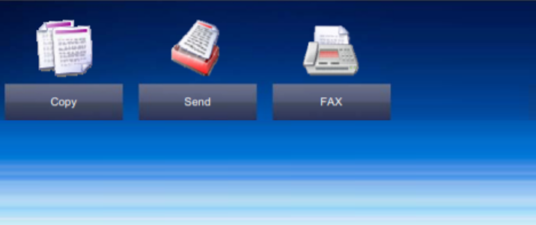
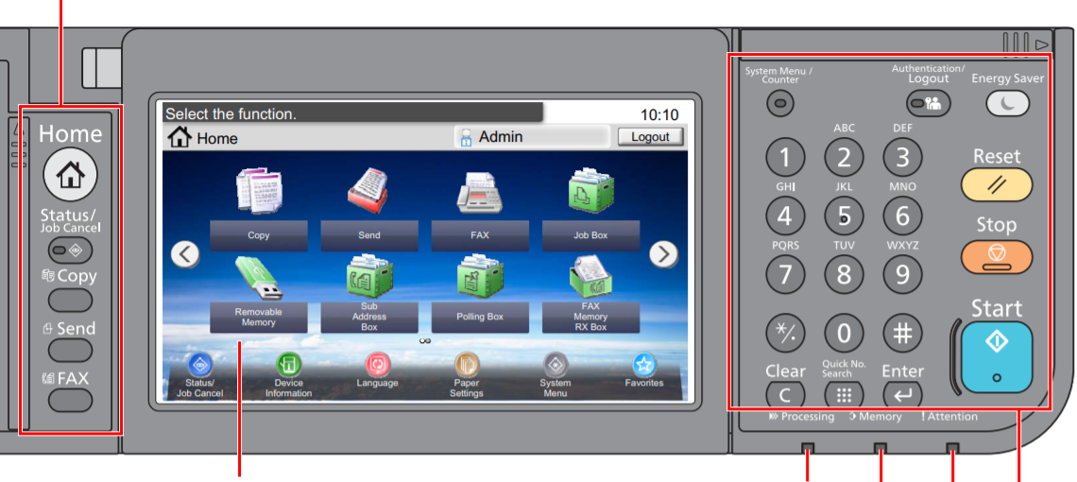
Blinks while printing or sending/receiving faxes
Touch panel

Blinks while memory is accessed (general purpose light)

Blinks while memory is accessed (general purpose light)

- The Reset button will return the machine’s settings to their default states.
- The Stop button will cancel or pause the job in progress.
- The Start button will start the copy, scan and fax operations.

Printing

To print from your computer, simply select the ECOSYS M6635cidn from the printer selection menu. If you do not have this option, contact the CATS team at CATS@queens.org and we will install the drivers.
It is able to print in color or black/white, double-sided (duplex) and collated (when you have multiple copies to print).
Copying

- Select the [Copy] button on the Home screen.

- Place the originals on the top feeder or the flat bed.
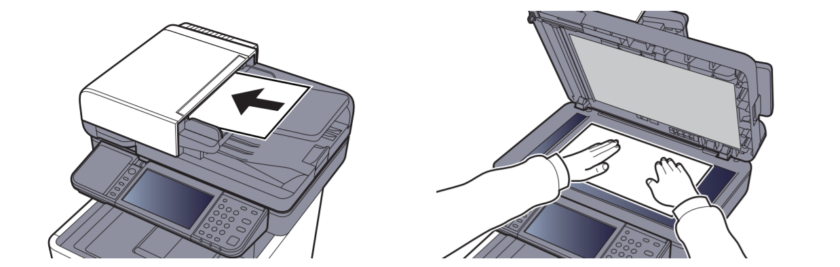

- If you need special settings, such as Duplex, use the keys in the Function Keys. Otherwise, skip this step.

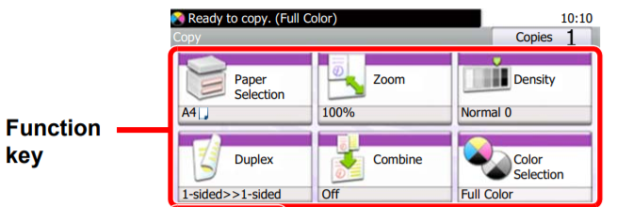

- Use the numeric keys to enter the copy quantity.

- Press the [Start] button.

Scanning (also known as Send)

- Select the [Send] button on the Home screen.

- Place the originals on the top feeder or the flat bed.

- Specify the destination by clicking on “Server Scan folder” or similar on the touch panel display.
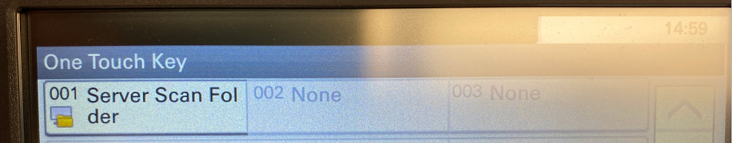

- If your originals are one side only, you can skip this step. Otherwise, click on “Functions” to adjust the settings, as needed.
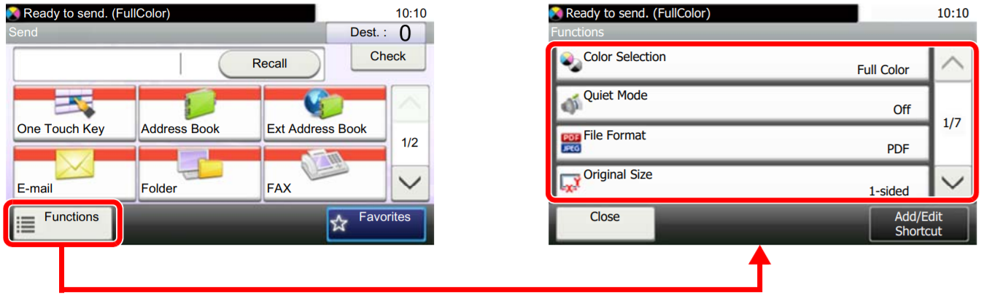

- Press the [Start] button.

- Retrieving the scanned files.
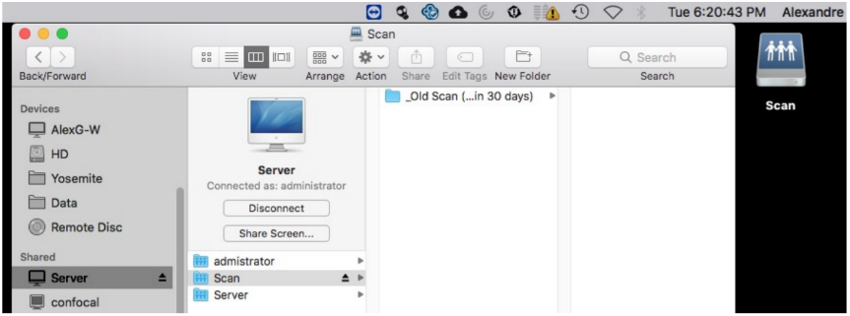
From your Mac:
- Open the finder and click on the “Server”.
- Click on the “Scan” folder.
- Move the documents on your desktop. Do not leave it in the folder, as everyone can read it.

Faxing

- Select the [FAX] button on the Home screen.

- Place the originals on the top feeder or the flat bed.

- Specify the destination Fax number by using the keypad numbers.
For local numbers, press “9” followed by the area code and then the number. E.g. 9808xxxxxxx.
For international numbers, press “9” followed by the country and area codes, then the number.

- If your originals are one side only, you can skip this step. Otherwise, click on “Functions” to adjust the settings, as needed.

- Press the [Start] button.

